FORWARD CHAINING
AIM
To develop a Prolog program that implements forward chaining by deriving new facts from existing facts and predefined rules.
OBJECTIVE
· To understand the concept of forward chaining in Artificial Intelligence.
· To represent knowledge using facts and rules in Prolog.
· To derive new facts automatically from existing facts.
· To execute the required queries and verify the derived conclusions.
ALGORITHM
1. Start the program.
2. Define the initial facts.
3. Define rules using the available facts.
4. Check whether the conditions of a rule are satisfied.
5. If the conditions are satisfied, derive a new fact.
6. Add the newly derived fact to the knowledge base.
7. Continue checking the rules until no new facts can be derived.
8. Display the derived facts.
9. Stop the program.
FLOWCHART
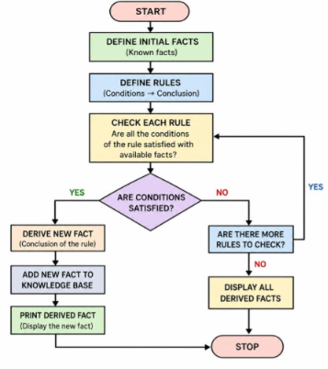
CODE
% FORWARD CHAINING PROGRAM
:- dynamic fact/1.
% INITIAL FACTS
fact(fever).
fact(cough).
fact(body_pain).
% RULES
rule(fever, cough, flu).
rule(cough, body_pain, infection).
rule(flu, infection, serious_flu).
% FORWARD CHAINING
forward_chain :-
rule(A, B, C),
fact(A),
fact(B),
\+ fact(C),
assertz(fact(C)),
write('Derived fact: '),
write(C),
nl,
fail.
forward_chain.
% START PROGRAM
start :-
forward_chain,
write('Forward chaining completed.'), nl.
OUTPUT
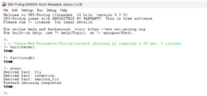
RESULT
Thus, the forward chaining program was successfully implemented in Prolog. The program starts with known facts, applies the predefined rules, derives new facts, and continues the process until all possible conclusions are obtained.

